**Fixed Income Homework 8**

**Cohort 2: Sajel Bharati, Huanyu Liu, Tongsu Peng, Justin Tan**

All **highlights** in questions refer to a **variable** in attached code file.

**1. Solve for the values of 2, 3, 4, 5, 7, and 10-year caps.**

Caps is the combination of a series of caplets (omit the first one). Therefore, we need to calculate the value of each caplet for each path, discount to present using its spot and forward D(t, t+0.5), sum up the value of caplets, and take the average to get the value of caps.

Using the formula from the TA notes, the caplet value is roughly,

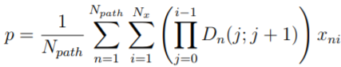

where x is the payoff function that $x=max⁡(L_{T-0.5}-K, 0)$.

Variable: **output1**

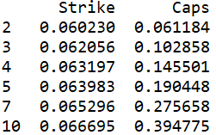

**2. Price the at-the-money forward European receivers swaption for the following structures: 1 into 1, 1 into 2, 1 into 3, 1 into 4, 2 into 1, 2 into 2, 2 into 3, 5 into 1, 5 into 2, 5 into 5.**

My process is as follows,

1. **Step 1**: Solve for the **forward par rates** for each structure of swaption as in homework 7 using the string model and simulation.
   1. These forward par rates would be used as strikes.
2. **Step 2:** Record the actual forward par rate for each path of the simulation and compare it with the strike. If the actual forward par rate is lower than the strike, exercise the swaption and enter into the receiver swaption to receive the fixed. The payoff is 0 otherwise.
   1. **Payoff = fixed leg value with strike par rate –** **1,** when actual forward rate < strike
3. **Step 3:** Discount the payoff to the present using the spot and forward D(t, t+0.5) simulated for each path.

Variable: **output2**

